The newest version of R package ***fuzzySim* (3.0) is now on** [**CRAN**](https://cran.r-project.org/package=fuzzySim)! It includes **new functions such as ‘*[favClass](https://modtools.wordpress.com/2019/03/04/calculate-biotic-threat-of-a-stronger-over-a-weaker-species/" \t "_blank)*‘, ‘*[bioThreat](https://modtools.wordpress.com/2019/03/04/calculate-biotic-threat-of-a-stronger-over-a-weaker-species/" \t "_blank)*‘ and ‘*[gridRecords](https://modtools.wordpress.com/2020/02/03/grid-point-occurrence-records-onto-a-raster/" \t "_blank)*‘**; improvements to some functions, help files and examples; **updated e-mail and citation information** [ see *citation(“fuzzySim”)* ]; clarifications and typo corrections along the reference manual; and some **bug fixes** (after changes to base R and/or to function dependencies), e.g. to ‘*[getPreds](https://modtools.wordpress.com/2013/07/24/getpreds/" \t "_blank)*‘ when applied to raster objects. You should now uninstall the old version of the package and install the new one:

remove.packages("fuzzysim")

install.packages("fuzzysim")

Among other new functionalities, *fuzzySim* now makes it **easier to use variable selection and presence-absence modelling techniques on occurrence points + raster variables**, as these are becoming the more common data formats in species distribution modelling (SDM) and ecological niche modelling (ENM). Here’s a worked example:

# download and plot predictor variables:

library(dismo)

worldclim <- getData("worldclim", var = "bio", res = 10)

plot(worldclim)

plot(worldclim[[1]])

# download and plot species occurrence data:

library(rgbif)

gbif <- occ\_data(scientificName = "Galemys pyrenaicus", hasCoordinate = TRUE, limit = 5000)

absence\_rows <- which(gbif$data$occurrenceStatus == "absent" | gbif$data$organismQuantity == 0)

if (length(absence\_rows) > 0) gbif$data <- gbif$data[-absence\_rows, ]

presences <- gbif$data[ , c("decimalLongitude", "decimalLatitude")]

points(presences)

# crop variables to extent of presence data:

worldclim\_crop <- crop(worldclim, extent(range(presences$decimalLongitude), range(presences$decimalLatitude)))

plot(worldclim\_crop[[1]])

points(presences)

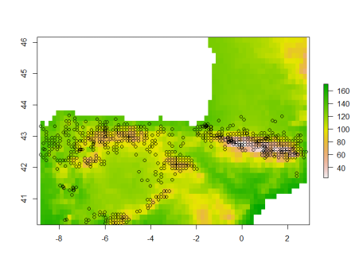

# model occurrence data as presence-absence in the cropped grid of pixels:

library(fuzzySim)

# first, get the centroid coordinates and variable values

# at pixels with and without presence records:

gridded\_presences <- gridRecords(rst = worldclim\_crop, pres.coords = presences)

head(gridded\_presences)

plot(worldclim\_crop[[1]])

points(gridded\_presences[gridded\_presences$presence == 0, c("x", "y")], col = "red")

points(gridded\_presences[gridded\_presences$presence == 1, c("x", "y")], col = "blue", pch = 20)

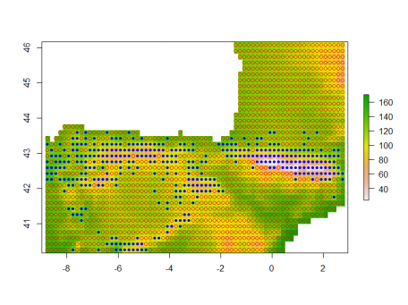

# then, build a GLM with variable selection on these presence-absence data:

names(gridded\_presences)

model\_GLM <- multGLM(data = gridded\_presences, sp.cols = "presence", var.cols = 5:23, id.col = "cells", FDR = TRUE, corSelect = TRUE, step = TRUE, trim = TRUE)

summary(model\_GLM$models$presence)

head(model\_GLM$predictions)

# finally, get and plot the model predictions (probability and favourability):

pred\_GLM\_raster <- getPreds(data = stack(worldclim\_crop), models = model\_GLM$models)

plot(pred\_GLM\_raster)

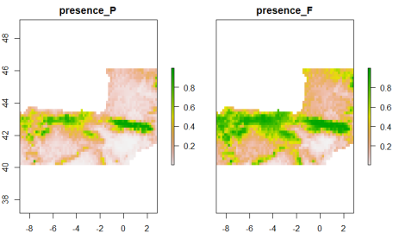

In case you’re worried about using a presence-absence modelling method on presence-only records, you can compare these predictions with those of a widely used presence-background modelling method (Maxent) on the same data, to check that they are not far off:

library(maxnet)

model\_maxent <- maxnet(p = gridded\_presences[ , "presence"], data = gridded\_presences[ , 5:23], f = maxnet.formula(p = gridded\_presences[ , "presence"], data = gridded\_presences[ , 5:23], classes = "lq")) # linear + quadratic features

pred\_maxent\_raster <- raster::predict(worldclim\_crop, model\_maxent)

plot(pred\_maxent\_raster)

